

**UNIVERSITY OF PETROLEUM AND ENERGY STUDIES**

**School of Computer** **Science**

**2020-21**

**GRAPHICS AND ANIMATION TOOLS LAB**

**Faculty: Dr. DURGANSH SHARMA**

**Assistant Professor**

**Department of Cybernetics.**

**School of Computer Science, UPES**

**Submitted By:**

**Name- Garima Dhall**

**Roll no-R100217025**

**Batch-B1**

**Semester- 7**

**Course-B.tech. CSE-OSOS**

**Sap Id- 500062498**

**EXPERIMENT NO 9**

**Aim** :- Design of 3D Mountains using Blender.

**Objective** :- To Design a 3D Mountains using features of Blender 2.8.

**STEPS TO MAKE DESIGN A 3D CAR:-**

1. Open Blender workspace and add a plane and then in edit mode we will subdivide it

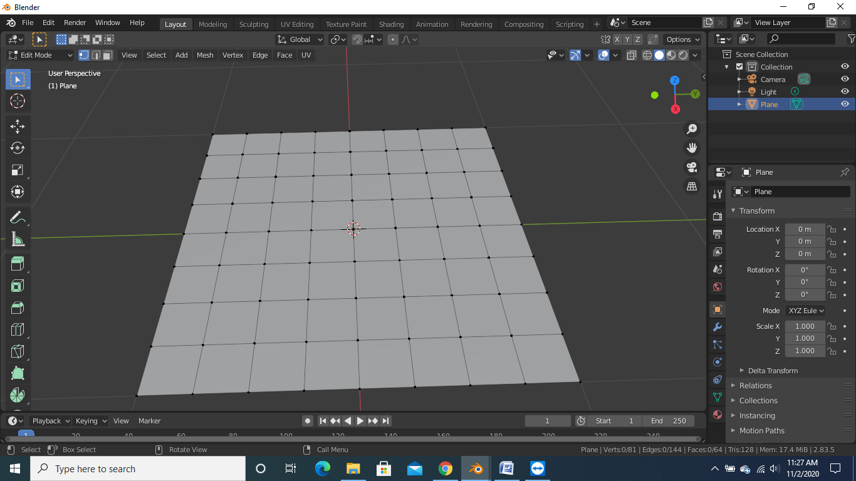

1. Then we will add a displace modifier and after that we will assign a cloud texture to it

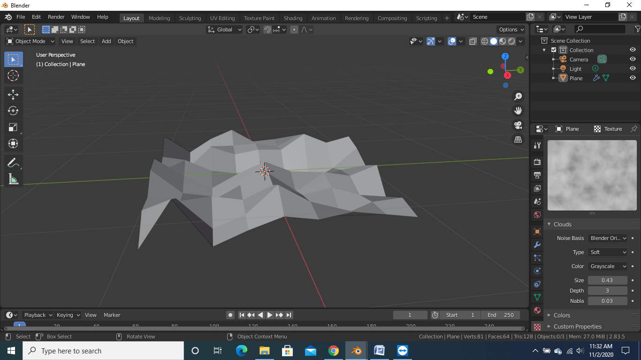

1. After doing the above step we will add an UV sphere and adjust it to the center of the plane and then we will open it in edit mode and select all the vertex and add them as a vertex group

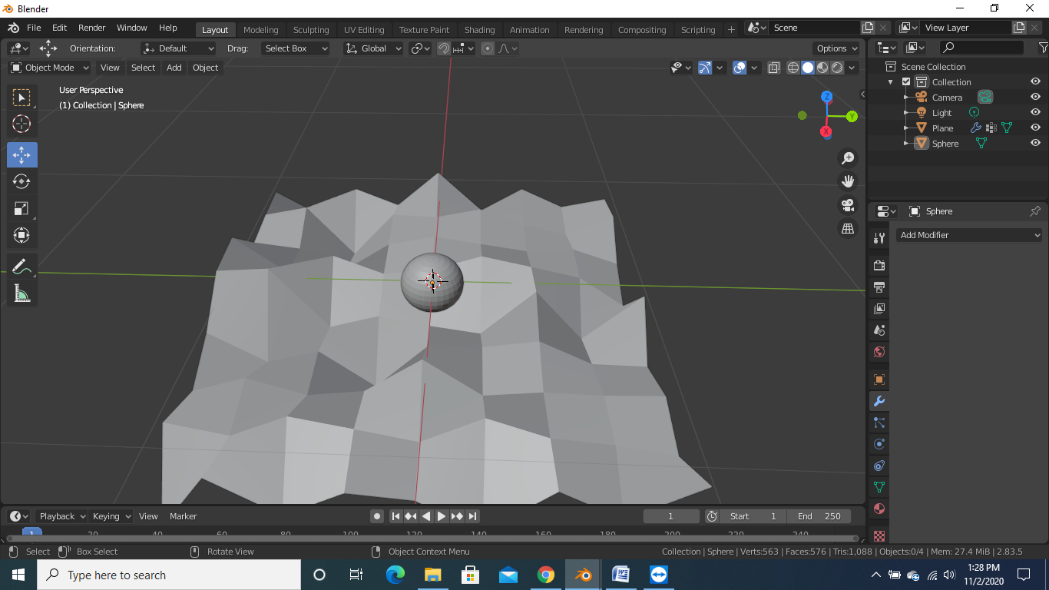

1. After the above step we will add a vertex weight proximity modifier and then we will make a adjustments that if we move sphere then we will able to control the plane and then we will combine all the vertex of the sphere and make them one point so that one single point control the plane

